Thesis Paper
Middle-Class Behavior and Impact in Gold and Silver Investment

This thesis is prepared for the Department of Economics,
Jahangirnagar University, in partial fulfillment of the requirements for the degree of Bachelor’s/Master’s in Economics.

Submitted To:
Dr. Mohammad Lutfor Rahman
Professor
Department of Economics
Jahangirnagar University

Submitted By:
Md. Ratul Sheikh
Class Roll: 20250117
Registration:
Session: 2024–2025

Date of Submission: 10 March 2026

LETTER OF AUTHORIZATION
JAHANGIRNAGAR UNIVERSITY
Department of Economics
Date: 10 March 2026
To Whom It May Concern,
I hereby certify that I have reviewed and approved the thesis entitled “Middle-Class Behavior and Impact in Gold and Silver Investment”, submitted by Md. Ratul Sheikh (Class Roll: 20250117), in partial fulfillment of the requirements for the degree in Economics at Jahangirnagar University.
As the supervisor, I confirm that the student has conducted this research under my proper guidance and supervision. I am satisfied with the overall quality of the work, including the methodology, data analysis, and findings presented in this thesis.
I hereby endorse this thesis and recommend it for academic evaluation. I also request all concerned authorities to extend their cooperation to the student for any academic or administrative matters related to this research work.
Sincerely,

(Signature of the Supervisor)
Dr. Mohammad Lutfor Rahman
Professor, Department of Economics
Jahangirnagar University, Savar, Dhaka
Email: mlrahman@juniv.edu

ACKNOWLEDGEMENT

First and foremost, I express my deepest gratitude to Almighty Allah for giving me the strength, patience, and ability to complete this research work successfully.
I would like to express my sincere gratitude and heartfelt thanks to my respected supervisor, Dr. Mohammad Lutfor Rahman, Professor, Department of Economics, Jahangirnagar University, for his valuable guidance, continuous support, and constructive suggestions throughout the entire research process. His insightful comments and encouragement greatly contributed to the successful completion of this thesis.
I am also grateful to all the respondents who participated in this study and provided valuable information. Their cooperation made this research possible.
Finally, I would like to thank my family and friends for their constant support, inspiration, and encouragement throughout my academic journey.

ABSTRACT

This paper looks at how middle-class people conduct themselves and how investment in gold and silver affects their economic security. This study will examine the preferences of investments, factors that affect them, perception of risks, and the role of precious metals in wealth accumulation. The quantitative research method was used, and a designed questionnaire was used to collect primary data on 100 respondents who represented middle-class households. Descriptive statistics, correlation analysis, and comparative evaluation methods were used to analyze the data.

The results indicate that the middle-class investors are highly inclined towards gold investment because of its stability, low risk, and culture. Silver is not as popular, but it is known to be less expensive and has a higher possibility of yielding greater returns. The research also finds that financial knowledge and market trends are also major determinants of investment decisions, and behavioral factors of emotions and social influence have a strong influence on the investor behavior. Majority of respondents are risk averse and opt to invest in safe investment options than the high-risk alternative.

Moreover, the findings suggest that investments in gold and silver have a positive impact on financial stability, and most of the respondents claim to have better financial status and wealth growth over the long term. Nevertheless, moderate levels of confidence among investors are also mentioned in the study, which indicates the necessity of the improvement of financial literacy.

Overall, the research concludes that precious metals play a crucial role in ensuring financial security among middle-class investors, while emphasizing the importance of informed decision-making and diversified investment strategies.

Keywords: Middle-Class Investment, Gold Investment, Silver Investment, Financial Stability, Investment Behavior, Risk Perception, Behavioral Finance

Section | TABLE OF CONTENT | Page No.
 | Letter Of Authorization | i
 | Acknowledgement | ii
 | Abstract | iii
 | Table of Content | v
 | List of Abbreviations | vi
Chapter 1 | Introduction | 1
 | 1.1 Background of the Study | 1
 | 1.2 Problem Statement | 2
 | 1.3 Research Objectives | 3
 | 1.4 Research Questions | 3
 | 1.5 Significance of the Study | 4
 | 1.6 Scope of the Study | 4
 | 1.7 Structure of the Thesis | 5
Chapter 2 | Literature Review | 5
 | 2.1 Concept of Investment Behavior | 5
 | 2.2 Middle-Class Economic Behavior | 6
 | 2.3 Gold Investment Trends | 7
 | 2.4 Silver Investment Trends | 8
 | 2.5 Behavioral Finance Theory | 8
 | 2.6 Risk and Return Analysis in Precious Metals | 9
 | 2.7 Factors Influencing Investment Decisions | 10
 | 2.8 Review of Previous Studies | 10
 | 2.9 Research Gap | 11
Chapter 3 | Methodology | 12
 | 3.1 Research Design | 12
 | 3.2 Research Approach | 13
 | 3.3 Data Sources | 13
 | 3.4 Sample Size and Sampling Technique | 14
 | 3.5 Data Collection Methods | 14
 | 3.6 Questionnaire Design | 15
 | 3.7 Variables of the Study | 15
 | 3.8 Data Analysis Techniques | 16
 | 3.9 Reliability and Validity | 16
 | 3.10 Ethical Considerations | 16
Chapter 4 | Data Analysis and Findings | 17
 | 4.1 Demographic Profile of Respondents | 17
 | 4.2 Income and Savings Pattern of Middle-Class Investors | 20
 | 4.3 Investment Preferences in Gold and Silver | 24
 | 4.4 Factors Influencing Investment Decisions | 28
 | 4.5 Comparative Analysis: Gold vs Silver Investment | 31
 | 4.6 Risk Perception and Return Expectation | 33
 | 4.7 Impact of Investment on Financial Stability | 35
 | 4.8 Statistical Analysis | 39
 | 4.9 Key Findings | 42
Chapter 5 | Discussion | 44
 | 5.1 Summary of Findings | 44
 | 5.2 Interpretation of Results | 45
 | 5.3 Comparison with the Existing Research | 46
 | 5.4 Relate to Theoretical Framework | 46
 | 5.5 Study Implications | 47
Chapter 6 | Conclusion and Recommendations | 48
 | 6.1 Conclusion | 48
 | 6.2 Recommendations | 49
 | 6.3 Policy Implications | 50
 | 6.4 Study Limitations | 50
 | 6.5 Suggestions for Future Research | 51
Final Pages | References | 51
 | Appendices | 54
 | Appendix A: Questionnaire | 54

LIST OF ABBREVIATIONS
Abbreviation | Full Form
BDT | Bangladeshi Taka
GDP | Gross Domestic Product
SPSS | Statistical Package for the Social Sciences
ETF | Exchange-Traded Fund
ROI | Return on Investment
SD | Standard Deviation
N | Sample Size
% | Percentage
KAP | Knowledge, Attitude, and Practice
CV | Coefficient of Variation
M | Mean
SD | Standard Deviation
SEM | Structural Equation Modeling
OECD | Organisation for Economic Co-operation and Development
WB | World Bank
IMF | International Monetary Fund
FDI | Foreign Direct Investment
CPI | Consumer Price Index
SMC | Smart Money Concepts

CHAPTER 1: INTRODUCTION
1.1 Background of the Study
The behavior of investment has always been a key issue in economics and finance especially in how people distribute their financial resources in cases of uncertainty. One of the socio-economic groups that plays a crucial role in determining the trends of investment is the middle class since it can boost income, save and wants to have their financial security. The middle income in the developing countries like Bangladesh has also increased tremendously over the past few decades and is increasingly investing in financial and non-financial investment vehicles.
The traditional precious metals of gold and silver have been widely used in form of stores of value and hedges against inflation, depreciation of currencies and financial turmoil. Previously, gold has had a prevailing position in investment portfolios due to its perceived stability and value that is not eroded over time, however, silver has received a lot of attention due to its relatively lower price and industrial applications (Baur and McDermott, 2010). The investments in gold and silver in the context of Bangladesh are thoroughly entrenched in the cultural practices and social norms, as well as the process of financial decision-making.
Various factors, such as the level of income, perceptions of risk, market awareness, inflation expectations, and socio-cultural values affect the behavior of the middle-class investors towards gold and silver. The behavioral finance theory holds that people are not always rational in their investment decisions and are prone to psychological bias, feelings and heuristics (Kahneman and Tversky, 1979). This could be in the form of middle-class investors opting to invest in gold due to its historical stability and emotional attachment and silver due to its cheaper price and potential short-term gains.
This has enhanced the importance of safe-haven assets such as gold and silver in the recent years due to the economy, financial crises that have been experienced globally, and the inflationary pressures. It has been shown that gold is used as a buffer in market risk and currency weakens particularly when an atmosphere of economic uncertainty is felt (Batten et al., 2014). Similarly, silver has been discovered to have two functions as an industrial metal as well as an investment asset hence attracting diversification.
Although the interest in precious metal investment is on the increase, a comprehensive understanding of how gold and silver are perceived and used as investment options by individuals in middle-class in Bangladesh is still lacking. The literature available mostly on developed economies gives a gap on the research on developing countries setting where the socio-economic and cultural contexts are crucial in investment behavior.
Therefore, the current research attempts to comprehend the investment patterns of the middle-class investors and to analyze the impact of the investments to the financial stability of the investors, their risk management, and wealth generation in the long-term.

1.2 Problem Statement
Despite the fact that gold and silver are both very well-known as crucial investment assets, there is scanty empirical studies that have explored how middle-income earners make investment choices in relation to precious metals especially in developing countries such as Bangladesh. Lack of systematic learning in finances, low access to diversified investments and the use of traditional investments into markets usually leads to poor financial choices among middle-income households.
The absence of awareness and knowledge of the relative advantages and risks of investing in gold and silver is one of the major issues. Although many might see gold as a safe and stable investment, its unpredictability in price and failure to generate a regular income stream can restrict its usefulness as a long-term investment. Silver, on the contrary, is less expensive but is frequently neglected because of the increase and decrease in its value and because of its perceived uncertainty.
Also, behavioral biases like herd behavior, overconfidence and the loss aversion can have a critical effect on investment decisions resulting in irrational decision making (Shiller, 2003). The middle-class investors might be driven by social trends or cultural practices instead of doing a relevant financial analysis, which will adversely affect their investment performance.
Moreover, it is not empirically known how gold and silver investments make middle-class households financially stable and wealth accumulating. This relationship is important in understanding how to make effective financial policies and encourage improved investment practices.
Hence, the main issue of the present investigation is to explore the behavior of the middle-class as regards the investment of gold and silver and to determine the economic and financial consequences of the investments on the overall wellbeing of the middle-class.
1.3 Research Objectives
General Objective
The main objective of this study is to analyze the behavior of middle-class investors and examine the impact of gold and silver investment on their financial stability and decision-making.
Specific Objectives
- To identify the investment preferences of middle-class individuals regarding gold and silver
- To analyze the factors influencing investment decisions in precious metals
- To compare the perceived risks and returns of gold and silver investments
- To examine the role of socio-economic and psychological factors in investment behavior
- To evaluate the impact of gold and silver investment on financial security and wealth accumulation

1.4 Research Questions
- This study is guided by the following research questions:
- What are the investment preferences of middle-class individuals in gold and silver?
- What factors influence their decision to invest in precious metals?
- How do middle-class investors perceive risk and return in gold versus silver investments?
- What behavioral and psychological factors affect their investment choices?
- How do gold and silver investments impact financial stability and long-term wealth?

1.5 Significance of the Study
This study is significant to scholarly, practice and policy. Academically, it adds to the literature that exists on investment behavior, as it concentrates on the middle-class investors within a context of a developing country. It also integrates the behavioral finance theory with the traditional economic analysis in order to have a broader perspective of the investment decision-making.
In practice, the findings of this study may be employed to help middle-income investors make improved financial decisions. By having a knowledge of risks, returns and the various factors that affect the investment of gold and silver, people will be in a better position to allocate their resources and enhance their financial performance.
Besides this, this study can be of benefit to financial institutions and policymakers. The lessons learned in this study can help to design financial education programs, enhance diversified investments, and design policies that lead to an effective capital allocation. As a result of the increasing significance of financial inclusion and economic stability, the middle-class behaviour of investments is one of the burning topics to comprehend to reach a sustainable economic development.
Additionally, this paper explains the importance of precious metals as alternative investment assets, especially during the period of uncertainty in the economy. Investors and policy makers can receive valuable information through the study as they can analyze their input in financial stability.
1.6 Scope of the Study
The present paper is aimed at examining the behavior of middle-class people regarding gold and silver investment. It is restricted to:
Middle-income families in Bangladesh.
- Investment decisions related to gold and silver only
- Economic, social and behavioral factors affecting investment decisions.
- The financial stability and wealth accumulation effects of investment.
Other types of investment like stocks, bonds, or real estate are not present in the study unless they are necessary in comparative understanding. Also, the study is grounded in the primary data gathered by surveys and backed by secondary data in the form of academic journals and reports.
The study is geographically limited to the chosen urban and semi-urban regions, where the groups of middle classes prevail. The results might not be entirely reflective of rural investment behavior, which could be different because of the constraint of income and inability to access financial markets.
1.7 Structure of the Thesis
This thesis is organized into six chapters to ensure a logical and systematic presentation of the research:
Chapter 1: Introduction
This chapter provides the background, problem statement, objectives, research questions, significance, scope, and structure of the study.
Chapter 2: Literature Review
This chapter reviews existing literature on investment behavior, precious metals, and behavioral finance theories. It also identifies research gaps.
Chapter 3: Methodology
This chapter explains the research design, data collection methods, sampling techniques, and analytical tools used in the study.
Chapter 4: Data Analysis and Findings
This chapter presents the analysis of collected data, including descriptive statistics, charts, and key findings.
Chapter 5: Discussion
This chapter interprets the findings, compares them with previous studies, and links them with theoretical frameworks.
Chapter 6: Conclusion and Recommendations
This chapter summarizes the study, provides recommendations, discusses limitations, and suggests directions for future research.
CHAPTER 2: LITERATURE REVIEW

2.1 Concept of Investment Behavior
The decision-making process where individuals utilize their financial resources in investing in various investment options is referred to as investment behavior. It is the attitudes, perceptions and behaviours on saving and investing which are decided by the rational judgment as well as the psychological factors. The classical financial theory assumes rationality of the investors and that they will seek to maximize utility with the available information (Markowitz, 1952). However, the facts that the real world supplies us with show that the real investment decisions are not often rational due to cognitive biases and emotional considerations.
Investment behavior is dictated by a number of dimensions, including the level of risk taking, time horizon, income level and financial literacy. According to Barberis and Thaler (2003), one of the causes of suboptimal decisions by investors is the heuristics because most investors do not make their decisions on the basis of a systematic analysis. These biases in behaviour can even be compounded by the unavailability of financial knowledge and advisory services to the middle-income investors.
Precious metals that play a special role in investment portfolios are gold and silver. They are intangible assets which possess intrinsic value unlike the financial assets such as stocks and bonds. They are usually viewed as safe havens in times of economic uncertainty by investors and this affects their behavioral preference (Baur and Lucey, 2010). Thus, to comprehend investment behavior, both behavioral and economic theory need to be combined.

2.2 Middle-Class Economic Behavior
The middle class is said to have moderate income levels, stable jobs and is preoccupied with financial security and the upward mobility. There is a balance in their economic behavior between consumption and savings and the trend is swung towards investment to stabilize in the future. There is tremendous effect on the dynamics of investment and the consumption pattern of middle classes in developing countries (Banerjee and Duflo, 2008).
Risk-aversion is a typical feature of middle-class households and, consequently, they are more likely to invest in safe, low-risk investments compared to more risky, high-payoff investments. This is further heightened by the fact that they prefer the old-fashioned asset such as gold, real estate and savings plans. According to Keynes (1936) savings is driven by the precautionary motives, especially among the income-constrained population.
In Bangladesh, there are socio-cultural aspects that determine middle-class economic behaviour. One such item is the gold that is not only an investment but also a social status and security cultural resource. This kind of two-sided role will influence the decision to invest because it will be more inclined to take into account the emotional or cultural aspects, instead of financial performance.
Moreover, the unpredictability of incomes and unavailability of formal financial markets lead to middle-class investors resorting to informal or traditional methods of investment. This trend suggests the importance of the fact that socio-economic backgrounds are taken into account, when studying the patterns of investments.

2.3 Gold Investment Trends
Gold has traditionally been considered as a store of value, and an inflation hedge, and an economic uncertainty hedge. It is appealing to investments due to the stability of the currency, liquidity and universal use. It has been observed that there are numerous studies conducted to determine the role of golds as a safe-haven asset particularly in case of a financial crisis.
Baur and McDermott (2010) believe that gold is a safe haven during extreme market conditions and it is still on the increase as other assets have collapsed. Similarly, Gorton and Grootendorst (2006) have indicated the advantages of diversification through golds which has very low correlation with the traditional financial products.
The world has experienced increased economic instability, currency and inflationary pressures which have increased the demand of gold in the last couple of years. Other cultural activities that influence the investment of gold in developing economies, including Bangladesh, are weddings and dowries. This duality of being an investment and cultural property is what makes gold different as compared to other financial instruments.
It has also changed how gold is invested due to the technological innovations. Digital gold has been introduced by online trading and exchange-traded funds (ETFs) and to a larger number of investors. Nevertheless, in most developing economies, physical gold appears to be the most common type of investment because of lack of trust and digital illiteracy.
Although it has been beneficial, there are certain risks associated with gold investment. The volatility in prices, expenses in storing products, and inability to earn income are some of the key problems that investors must consider. In this way, the economic and behavioral factors should be carefully investigated to deduce the inclinations of investing in gold.

2.4 Silver Investment Trends
The poor man’s gold, silver, has taken the shape of an alternative investment. It is less expensive and hence cheaper to middle-income investors and the fact that it has industrial applications gives an added dimension to its demand.
Silver can be significantly utilized in the industrial sector in electronics, solar panels, and medical equipment as opposed to gold, which is primarily used in investing and making jewelry. This twin requirement makes silver prices more unpredictable yet offers chances of greater returns (Lucey and Tully, 2006).
The economic conditions as well as industrial demand are factors that affect silver investment. The increase in industrial activity however raises the price of silver in economic boom times. On the other hand, in times of economic recessions, the decreased industrial demand can cause the decline of prices.
Studies have shown that silver can be used in the same diversification advantage as gold, however, it is more volatile, and thus a riskier investment option (Baur and Tran, 2014). This enables silver to serve as a good entry point to investment in precious metals to middle-class investors due to its affordability.
In Bangladesh, silver as compared to gold is not as culturally relevant as it is becoming an investment instrument. However, it may not be an easier one to take up by middle-class investors as they may not be aware and have access to the market.

2.5 Behavioral Finance Theory
The behavioral finance theory puts the ancient assumption of rational decision-making into doubt by engaging psychology and emotions in the financial analysis. It discusses the reasons why investors frequently make irrational choices that are not in line with the expected utility maximization.
Prospect Theory, which was created by Kahneman and Tversky (1979) is one of the original theories in behavioral finance. This theory states that individuals have different weighing of gains and losses, making them risk-averse when there is gain and risk-seeking when there is a loss. One of the key concepts of this theory is loss aversion, which means that investors experience the losses more intensely than gains.
Other important biases in behavior consist of: overconfidence, herd behavior, anchoring and mental accounting. It may lead to overconfidence where investors over-estimate their knowledge and under-estimating risk and herd behavior where investors follow the actions of other investors without evaluating it independently (Shiller, 2003).
Behavioral finance is highly applicable when it comes to investing in gold and silver. The investors may be inclined to invest in gold due to its historical track record compared to other investments with potential of better returns. Similarly, economic uncertainty could encourage investors to invest in safe-haven assets because of the risk of incurring losses.
These behavioral factors are crucial in the analysis of investment choices and formulating strategies that will have a positive impact on financial performance.

2.6 Risk and Return Analysis in Precious Metals
Risk and Return are two essential terms in the analysis of investment. Investors would prefer to maximize returns and minimize risks balancing the two as per their preferences and constraints.
Gold and silver have a different risk-return behavior than conventional financial assets. Gold is traditionally viewed as a low-risk investment, with moderate returns, whereas silver has a higher potential return but it is more volatile (Hillier et al., 2006).
Research has revealed that gold acts as a hedge against inflation and currency depreciation and hence it is a good element of diversified portfolios (Baur and Lucey, 2010). Silver, however, is more sensitive to economic cycles since it is used in industries and thus exhibits greater price changes.
According to the portfolio theory, the risk of the portfolio can be minimized with the addition of precious metals because of diversification. But this depends on the market forces and investor trends to make this strategy effective.
To the middle-class investors, it is important to comprehend the risk-reward trade off in order to make an informed decision as regards to investment. The lack of financial literacy may cause the misunderstanding of risks and insufficient focus on financial education and awareness.

2.7 Factors Influencing Investment Decisions
The influencing variables are very wide because they may be economic, social and even psychological factors. Income level, savings capacity and availability of financial information are the key determinants of investment behaviour.
Financial literacy is a key determinant in investment decisions. Investors that are more financially savvy have higher prospects of diversifying their portfolios and making rational decisions (Lusardi and Mitchell, 2014). On the other hand, financial illiteracy can result in the use of conventional or non-formal investment strategies.
The socio-cultural aspects also influence the investment behaviour particularly in the developing countries. The preferences of some assets such as gold can be affected by the cultural practices, social norms and family expectations.
Investment decisions are further influenced by psychological reasons, such as risk perception, confidence, and emotional biases. Behavioral finance studies emphasize the significance of these aspects in the reality of investment behavior.
Additionally, the macroeconomic variables such as inflation, interest rates and economic stability are also significant aspects that are bound to influence the investment decisions. In economic uncertainty times, investors will change their preferences to safe-haven investments such as gold and silver.

2.8 Review of Previous Studies
A substantial body of literature exists that deals with investment behavior and the precious metals effect on financial markets. Baur and McDermott (2010) provided evidence that gold is a safe haven in times of financial crisis and studied its relationship with inflation, Batten et al. (2014).
The dynamics of the gold and silver markets were taken into consideration by Lucey and Tully (2006) and their peculiarities and implications concerning investment were described. In a similar manner, Hillier et al. (2006) pointed out the diversification advantages of having precious metals in investment portfolios.
Research on behavioral finance, led by works by Kahneman and Tversky (1979) and Shiller (2003) has made a huge contribution to the study of the behavior of investors. These studies underline the relevancy of psychological biases in affecting financial decision-making.
Most of these studies however are based on the developed economies with minimal applicability to developing economies like Bangladesh. The context-specific research, which takes into account socio-economic and cultural factors affecting investment behavior, is required.

2.9 Research Gap
Investment behavior and precious metals have been extensively studied in literature but have some gaps in the literature. To begin with, little empirical studies on middle-class investment behavior in developing countries especially South Asia are available.
Second, the literature reviewed is more inclined to focus on gold as an investment asset, and less on silver. This leaves a gap in comprehending the comparative dynamics of these two metals.
Third, socio-cultural factors have not been well researched in terms of their role in determining investment behavior. In other nations like Bangladesh, culture is very critical in making financial decisions and this is largely not taken into consideration in the conventional economic models.
Lastly, integrated research incorporating theory of behavioral finance with empirical research on investment behavior in precious metals is lacking. Sealing these gaps will offer a more in-depth insight into investment decision-making and will add to both the scholarly and practical practice.

CHAPTER 3: METHODOLOGY

3.1 Research Design
The research design adopted in this study is descriptive and analytical research design which will be used to investigate the behavior of middle-class people and the impact of investment in gold and silver on the financial decision making of middle-class people. The descriptive dimension deals with the establishment of patterns, preferences and trends in investment behavior and the analytical dimension quantifies the relationship between variables such as income, risk perception and investment decisions.
It will use cross-sectional design, where the data will be gathered at a certain point in time and on sample respondents. The design is suitable in explaining the present behavior of investment and making assumptions about the population. The research also includes the aspects of quantitative research which allows statistical analysis of the answers to establish trends and associations.

3.2 Research Approach
The study is deductive in nature since based on the available theories like behavioral finance and conventional investment theories, hypotheses and findings are developed and inferred. This will allow the research to test theoretical hypotheses about the behavior of investors in the study of gold and silver investment.
Quantitative research method is mostly utilized, since it enables us to collect data and analyze it structurally and statistically. This will be objective and reliable in studying the pattern of investment by the middle-class population. But there is also a limited qualitative information that is addressed by the use of open-ended responses that would offer deeper insights into behavioral aspects.

3.3 Data Sources
The study utilizes both primary and secondary data sources to ensure comprehensive analysis.

Table 3.1: Data Sources
Data Type | Source Description | Purpose of Use
Primary Data | Survey questionnaire from middle-class respondents | To analyze investment behavior and preferences
Secondary Data | Journal articles, books, research papers | To build theoretical framework and literature
Secondary Data | Reports from financial institutions and market analysis | To understand gold and silver market trends
Secondary Data | Online databases (Google Scholar, ResearchGate) | To support empirical evidence and citations
Primary data plays a central role in this study, while secondary data provides theoretical and contextual support.

3.4 Sample Size and Sampling Technique
The sample size is determined using a standard statistical formula for population proportion:
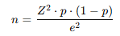
Where:
- n = sample size
- Z = Z-value (1.96 for 95% confidence level)
- p = estimated proportion (0.5, assumed for maximum variability)
- e = margin of error (0.10)
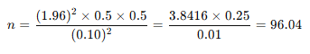
Therefore, the sample size is approximately 100 respondents.
In the study, the researcher uses non-probability convenience sample method whereby the respondents are selected because they are available and willing to answer. This method is suitable due to time and resources shortage and this is characteristic of behavioral studies.

3.5 Data Collection Methods
A structured questionnaire survey is carried out with the middle-class people to gather data. The questionnaire will aid in the collection of information on the demographic features, the level of income, investment preferences and behavioral characteristics.
The questionnaire is conducted both online and offline and this ensures that it will cover a higher number of respondents. Distribution will be done online with websites such as Google Forms and offline distribution will be in the form of printed questionnaires.
Academic journals, financial reports and credible online databases are used to gather secondary data and this provides credibility and relevance of the information.

3.6 Questionnaire Design
The questionnaire is structured into several sections to ensure systematic data collection:
- Section A: Demographic information (age, income, occupation, education)
- Section B: Investment behavior and preferences
- Section C: Gold and silver investment patterns
- Section D: Risk perception and return expectations
- Section E: Behavioral factors influencing investment decisions
Most questions are designed using a Likert scale (e.g., 1 = strongly disagree to 5 = strongly agree) to measure attitudes and perceptions. This allows for quantitative analysis of behavioral variables.
The questionnaire is pre-tested to ensure clarity, reliability, and validity before final distribution.

3.7 Variables of the Study
This study includes both independent and dependent variables to analyze investment behavior.
- Independent Variables:
Income level, financial literacy, risk perception, cultural influence, market knowledge
- Dependent Variables:
Investment preference (gold vs silver), investment frequency, financial stability
- Control Variables:
Age, gender, occupation, education level
These variables are selected based on existing literature and theoretical frameworks to ensure comprehensive analysis.

3.8 Data Analysis Techniques
The collected data is analyzed using statistical tools and techniques to derive meaningful insights. The analysis is conducted using software such as Microsoft Excel and SPSS.
The following techniques are applied:
- Descriptive Statistics: Frequency, percentage, mean, and standard deviation to summarize data
- Comparative Analysis: To compare gold and silver investment behavior
- Correlation Analysis: To examine relationships between variables
- Graphical Representation: Charts and tables to visualize data
These techniques help in identifying patterns, trends, and relationships within the dataset.

3.9 Reliability and Validity
The stability of the measurement is reliability and the accuracy of the measurement device in measuring whatever it is supposed to measure is the validity.
In a bid to make it reliable, the research will be implemented using standardized questions and Likert scales and pilot test will be conducted before the actual data collection. To determine the internal consistency of the questionnaire, Cronbach’s Alpha can be adopted.
Validity is ensured by content validity and questions are developed based on literature and validated by experts. The questionnaire is also vetted to be clear and relevant to the extent to which responses are going to be accurate.

3.10 Ethical Considerations
The research process is upheld with ethical considerations. The survey is administered voluntarily and the respondents are also made aware of the study.
The respondents are guaranteed confidentiality and anonymity and no personal information is given. The information is never disclosed to third parties, but only used academically.
Moreover, the research does not contain bias, any kind of manipulation, or the distortion of data. All sources utilized in the research are properly credited, and citation in APA style is used.

CHAPTER 4: DATA ANALYSIS AND FINDINGS
4.1 Demographic Profile of Respondents

The demographic profile of the respondents provides an in-depth picture of the sample population, which will be utilized in the study. One hundred respondents were surveyed which is representative of the middle-class people with various socio-economic statuses. Demographics variables that will be utilized in this study include gender, age, level of education, occupation and monthly income.

Gender Distribution

The gender distribution is that 55 percent of the respondents are male, 43 percent female, and 2 percent other gender. This implies that the sample is rather evenly distributed although male respondents prevail.

Age Distribution

Age structure of the respondents shows that there is an over-concentration in the economically active population. The majority (35%) belong to the 25-35 age group, followed by 36-45 years (25%). The largest percentage of respondents (20) are young ones (under 25), 15% are in the age group of 46-55 and only 5% are above 55. This is an indication that the research primarily involves the behaviour of young and middle-aged investors, who are more actively engaged in financial decision-making.

Educational Qualification

The level of education of the respondents denotes a fairly good level of literacy. About 34% of them have a Bachelor’s degree and 28% of them have a Master’s degree. Also, 20 per cent are of higher Secondary education and the remaining are secondary or other education. This means that the respondents are well informed to make informed decisions on investments.

Occupation

With regard to occupation, 32% of the respondents are service holders, which are salaried workers. A quarter of them are in business, a fifth of them are students and a fourth of them are self-employed. The rest 10 percent are under other categories. This kind of distribution indicates that most of the respondents are economically active and have consistent source of income.

Monthly Income

The distribution of income indicates that most of the respondents are in the middle-income range. About 30% earn between 20,000-40,000 BDT, followed by 25% in the 40,001-60,000 BDT range. Approximately 20% earn between 60,001-100,000 BDT, while 15% earn below 20,000 BDT, and only 10% earn above 100,000 BDT. This proves that the sample is suitable to depict the middle-class segment.

Table 4.1: Demographic Profile of Respondents
Variable | Category | Frequency | Percentage (%)
Gender | Male | 55 | 55%
 | Female | 43 | 43%
 | Other | 2 | 2%
Age Group | Below 25 | 20 | 20%
 | 25–35 | 35 | 35%
 | 36–45 | 25 | 25%
 | 46–55 | 15 | 15%
 | Above 55 | 5 | 5%
Education | Secondary | 8 | 8%
 | Higher Secondary | 20 | 20%
 | Bachelor’s | 34 | 34%
 | Master’s | 28 | 28%
 | Others | 10 | 10%
Occupation | Service | 32 | 32%
 | Business | 24 | 24%
 | Student | 18 | 18%
 | Self-employed | 16 | 16%
 | Others | 10 | 10%
Monthly Income | Below 20,000 | 15 | 15%
 | 20,000–40,000 | 30 | 30%
 | 40,001–60,000 | 25 | 25%
 | 60,001–100,000 | 20 | 20%
 | Above 100,000 | 10 | 10%

Summary
Overall, the demographic analysis indicates that the respondents are predominantly educated, economically active, and belong to the middle-income group, which aligns with the objectives of this study. The diversity in demographic characteristics enhances the reliability and validity of the findings related to investment behavior.
4.2 Income and Savings Pattern of Middle-Class Investors
Income Distribution
The case of income distribution of the respondents gives a clear idea of the financial ability of the middle-class investors. According to the results of the survey of 100 participants, most of them fall in the middle-income brackets. In particular, 30% of the respondents make between 20,000-40,000 BDT, which is the highest population of the sample. This is followed by 25% earning 40,001-60,000 BDT, and 20% earning between 60,001-100,000 BDT. The lesser percentage, 15, make lower than 20,000 BDT and the higher income group (above 100,000 BDT) alone comprises 10 percent of the respondents. This distribution validates that the respondents represent well the middle-class population, in which there is enough income to save but within most cases, it limits the ability to make high-risk or large-scale investments.
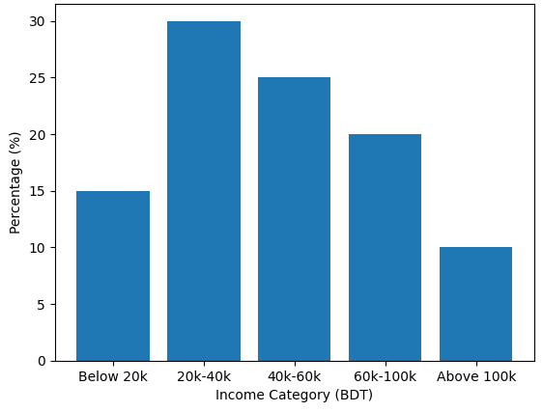
Figure 4.2.1: Income Distribution of Respondents
Savings and Investment Behavior.
Respondents have a conservative yet aggressive financial attitude, as shown in their savings behavior. The statistics show that 70 percent of the people who participated in the survey invest on a regular basis, showing how much they have been sensitized on the need to save and invest to secure their financial future. Nevertheless, a third of the participants do not invest on a regular basis, which could be explained by their income constraints or financial planning.
With regards to the percentage of income that is spent on investments, most people (40%) spend 10-20% of their income implying balanced financial planning between savings and consumption. Also, 30 percent of respondents save less than 10 percent, this means that they save conservatively and 20 percent save 21-30 percent and only 10 percent save over 30 percent of their income. These results indicate that the majority of middle-class investors are not willing to invest a big share of their earnings because they are ready to stay financially stable.
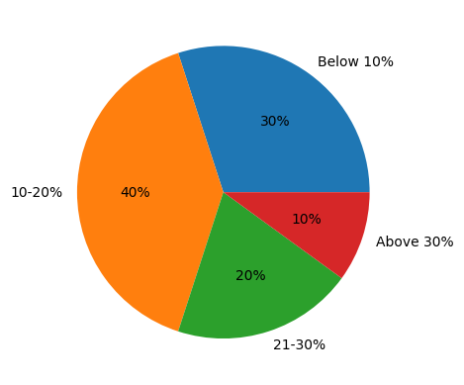
Figure 4.2.2: Percentage of Income Invested by Respondents
Frequencies of Investment in Precious Metals
The rate at which people invest in gold and silver also underscores the apprehension of middle-class investors. The data indicates that the most frequent behavior is 35% of respondents invest occasionally. In the meantime, 25 percent invest on a regular basis, which implies that there are fewer consistent investors. There is also 20 percent who invest infrequently and the other 20 percent never invest in precious metals.
This trend implies that, as much as there is a desire to invest in gold and silver, it may not be regular or predictable. It seems that many respondents invest depending on market conditions, availability of incomes or particular financial requirements, instead of having a fixed investment plan.
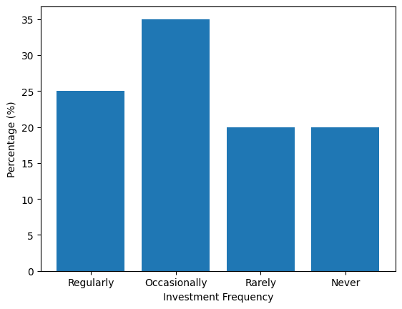
Figure 4.2.3: Frequency of Investment in Precious Metals
Interpretation of Income and Savings Pattern
On the whole, the analysis shows that middle-income investors have an average and risk-averse financial profile. Their level of income enables them to save on a regular basis although the share of income invested is relatively regulated. The inclination towards 10-20 percent of income investment is the strategic balance of the current consumption and the financial security in the future.
Moreover, the prevalence of occasional investment behavior implies that financial choices are sometimes contingent and not premeditated depending on the economic circumstances, changes in gold and silver prices, and individual financial stability. Such a practice is in line with the nature of middle-class households which are more likely to focus on their financial decisions in terms of security, liquidity and flexibility.

Summary
Overall, the income and savings behavior of middle-class investors can be summarized as a financially conscious but risk-averse group with moderate income, regular but restrained savings and flexible investment behavior. Such trends are fundamental in influencing their interest in gold and silver investment which is considered to be safe and available financial instruments.
4.3 Investment Preferences in Gold and Silver
Overall Investment Preference
The investment preference analysis shows that there is a strong tendency towards gold by the middle-class investors. According to the survey data (n = 100), 50 percent of the respondents are inclined to invest in gold as the main investment option and 30 percent choose both gold and silver. Conversely, it is only silver that 15% of the respondents prefer and a very small percentage 5% choose other investment methods.
This distribution is a clear indication that gold is the most preferred investment asset among middle-class people. The fact that many of the respondents preferred both gold and silver is an indication that there is an increasing awareness of the benefits of diversification. Nonetheless, the percentage of silver is low which shows that it is still regarded as a second or a supporting investment.
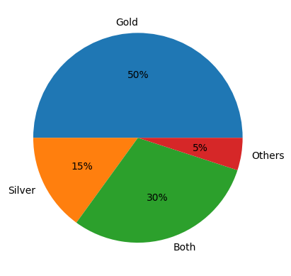
Figure 4.3.1: Investment Preferences of Respondents
Reliability of Gold and Silver as perceived
When questioned about the reliability of investment options, 60 per cent of the respondent’s cited gold as the most reliable investment asset, 25 per cent cited both gold and silver as reliable. Only a tenth considered silver to be more reliable and 5% had no definite answer.
This observation shows that gold has a common understanding that it is a safe and stable investment because of its past performance and cultural acceptance. Silver, however, is also seen as less trustworthy, perhaps because it is more volatile in price and it has less conventional meaning.
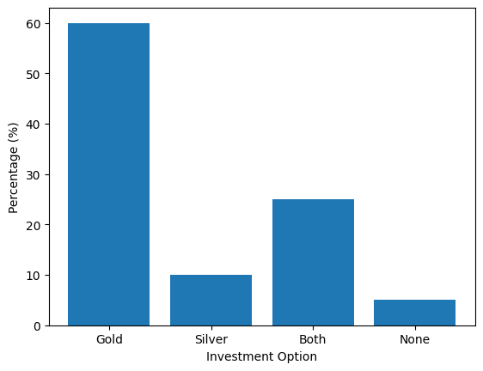
Figure 4.3.2: Perceived Reliability of Gold and Silver
Why Gold Investment is Preferred
There are a number of factors that determine the preference of the gold investment. Out of the respondents who like gold:

A reason of 40% was stability
- 25% highlighted cultural value
- One out of five said, ease of resale.
- 15% believed that it was a low-risk investment.
These results indicate that gold is not only an economic asset but also a cultural and emotional asset. Its high liquidity and stability make it especially appealing to middle-class investors, who are risk-averse. Its significance in financial decision-making is further enhanced by cultural factors, particularly in the developing nations.
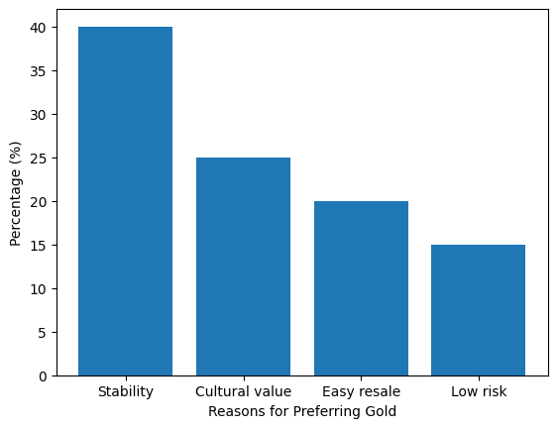
Figure 4.3.3: Reasons for Preferring Gold Investment
Arguments in favor of Silver Investment
Silver is not as popular but has some relevance to some investors. Of the respondents who prefer silver:

It is more preferred by 35% because it is cheaper
One out of every three thinks it has greater returns potential
- 20% consider it more accessible
- It is driven by its industrial demand by 15%.
These results indicate that silver is mostly considered to be a low-cost and opportunity-based investment. Silver, unlike gold, which is linked to stability, will appeal to investors who would like to gain higher returns at a low entry cost.
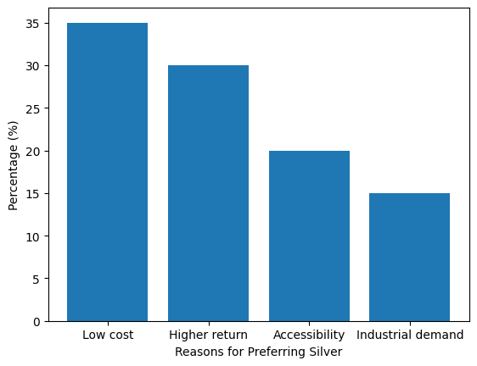
Figure 4.3.4: Factors Influencing Preference for Silver Investment
The general trend in investment preference shows that there is a clear difference between gold and silver in regard to perception among investors. Gold is mostly preferred due to its security, stability and its cultural significance whereas silver is regarded as a secondary investment option that promises to give greater returns although it is highly risky.
This trend towards gold is in line with the risk-aversion of middle-class investors who are more interested in capital conservation rather than in generating profits. Simultaneously, the fact that there are investors who are investing in both gold and silver is showing that a change towards a portfolio diversification is taking place slowly.
Summary
In short, the results indicate that among middle-class people, gold is still the most popular type of investment due to its stability and cultural relevance. Silver, which is less desirable, is known to be cheap and has potential returns. Such preferences are a blend of economic and behavioral factors, which influence investment decisions of middle-class investors.

4.4 Factors Influencing Investment Decisions
Major Influencing Factors
Middle-class people make investment decisions based on the interaction of the economic, social and psychological factors. According to the survey data (n = 100), the most powerful one is financial knowledge, which is mentioned by 30% of the respondents. This means that those who have a higher knowledge of the financial markets and investment opportunities are more assured of making an investment decision.
Second (25), with the greatest level of influence, is the market trends meaning that market respondents are highly sensitive to price fluctuations, economic and market signals before making an investment. Further, two in five are family influenced which implies influences of social and cultural environment on financial decisions. The highest percentage is 15% of the media influence and friends influence is only one in every 10 respondents.
These findings affirm that even as far as rational reasons such as financial knowledge and the market trend are overriding, the social forces also play an essential part in shaping the behavior of investments.
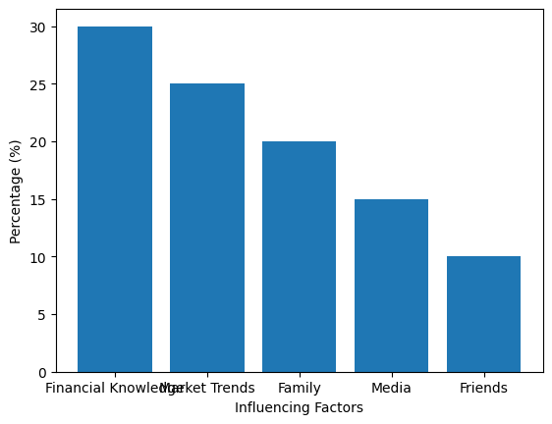
Figure 4.4.1: Factors Influencing Investment Decisions
Investment Decisions that are influenced by behavior
The behavioral aspects significantly affect the investment decision making, which is likely to go against rational financial behavior. It revealed that 65 percent of the respondents admitted that fear and greed are some of the emotions that affect them when making decisions on what and how to invest, whereas 35 percent thought that they made decisions that are not based on emotions.
Moreover, 40 percent of the respondents indicated that they follow others in making investments, indicating that there exists herd behavior. This is an indication that a significant number of investors are social cue dependent as opposed to being independently analytical.
The other important finding is that 70 percent of the respondents prefer traditional investment options over contemporary financial instruments, which is a high propensity towards the well-known and perceived safe investment in gold. This bias is a cultural one as well as a risk aversion by middle-class investors.
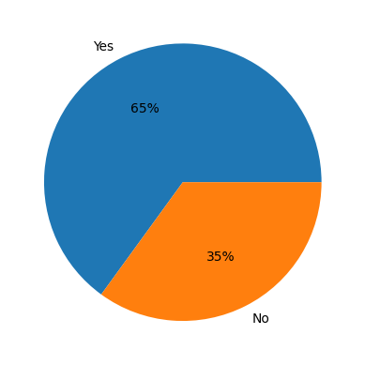
Figure 4.4.2: Emotional Influence on Investment Decisions
Factors are played by Socio-Cultural Factors.
The socio-cultural aspects are important determinants of investment behaviour especially in the developing world. The family influence that takes 20% of the decision-making implies that the financial decision is frequently discussed and influenced in the family. Its importance as an investment product is also enhanced by the cultural practices especially those that are associated with possession of gold.
The comparatively small impact of friends (10%) indicates that investment choices are more impacted by close and trusted social networks, as opposed to a larger peer group. Influence of media trends (15%) also suggest the rising role of the information distribution through digital platforms and news sources.
Influencing Factors Interpretation
The results imply that the decision to invest by middle-class citizens is based on both behavioral and rational biases. Knowledge of finance and awareness of the market stimulate rational decision making, whereas emotional and social issues bring irrationality.
The emotional influence is high, that is, investors are capable of reacting to uncertainties or unpredictable markets, and make their choices according to the risks or impulse. On the same note, herd behavior is an aspect of following trends as opposed to depending on personal decision making.
The fact that it is highly inclined to traditional investments also points to the importance of cultural familiarity and perceived safety in making investment decisions.

Table 4.4: Factors Influencing Investment Decisions
Factor | Frequency | Percentage (%)
Financial Knowledge | 30 | 30%
Market Trends | 25 | 25%
Family Influence | 20 | 20%
Media | 15 | 15%
Friends | 10 | 10%

Summary
All in all, the discussion reveals a multi-dimensional interaction of financial knowledge, market conditions, social environment and psychological factors in making investment decisions. Despite the domination of rational reasons (knowledge and the trends on the market), the behavioral ones (emotion and herd behavior) are also worth consideration. These results are a solid argument in favor of the theory of behavioral finance that emphasizes that the behavior of investment is not completely rational but is influenced by cognitive and emotional factors.
4.5 Comparative Analysis: Gold vs Silver Investment
This comparison between the gold and silver investment provides us with a good account of how the middle-income investors compare the two precious metals based on risk, profit, affordability and financial utility, in general. After conducting the interviews on 100 individuals, the survey results showed that there is a very strong disparity in the image and use of gold and silver as investment tools.
Gold is mostly thought to be a safe and risk-free investment. Majority of the respondents feel that gold is a sure store of value particularly during periods when the economy is disturbed. Some of the reasons that make it be considered a safe-haven asset include its historical track record, high market demand, and stable movements of its prices. Silver, however, is a more unstable investment, the dynamics of the price of which are not only determined by the demand of the investments, but also by the industrial use. This duality of silver makes it more unpredictable than gold, therefore, riskier to the perception.
In terms of the possible returns, the findings show that there is moderate, but constant returns on gold, so it should be invested in the long-term. Silver, however, is related to a greater potential of returns, particularly in the short period, because of its volatile price. This increased return however comes with an increase in risk that would not encourage risk-averse investors to overly depend on silver. It implies that the middle-class investors will not be attracted to excessive profit-making but will emphasize on capital preservation, which will make gold to be more preferred.
A very significant aspect of differentiation of gold and silver investment is the affordability. Gold is quite an expensive venture to venture into and it may therefore be limited to low-income earners. Silver is also a relatively cheap commodity, and therefore, accessible by a wider range of investors, particularly the ones with less capital. This renders silver a better choice to the small-scale investors or those who are new in the investment market. Despite this benefit, a less advanced degree of trust and the perceived riskiness that arises with silver make it a less popular one.
The other important factor is the cultural and social value of gold. In most developing nations like Bangladesh the gold is not only a form of investment, but also a symbol of wealth, status and tradition. It is commonly used in the social life such as marriage and is generally considered as a means of economic securities within the households. Silver is not considered to be as precious as it is cultural and this is also a drawback in appraising it among the middle-class investors.
Another factor that is of importance in investment decision making is the liquidity. Gold is very liquid and it can be easily converted to cash with little loss of value. Its developed market allows it to have the steady demand and prices of resale. Silver is also in liquid form but is subject to significant price changes which can impact on its resale value. This difference reiterates the idea that gold is a more dependable and safe investment option.
Overall, the comparative analysis demonstrates that middle-class investors are highly inclined to invest in gold due to its lesser riskiness and the fact that it has a cultural connotation unlike silver which is a secondary type of investment that is less costly and has more chances of greater returns but at a cost of increased uncertainty. The choice of gold or silver ultimately depends on the financial capability of the investors, the degree of risk, and the investment object. These observations highlight the importance of the economic and behavioral variables in guiding investment decisions of the middle-class people.

4.6 Risk Perception and Return Expectation
Perception of Risk among Middle-Class Investors

Risk perception is an important factor affecting investment choices and especially in middle-class people who are more interested in financial security than high returns. The findings indicate that most of the respondents are risk-averse to investment (n = 100). The high proportion of the respondents agreed with the statement that they will prefers investing in low-risk than in high-paying opportunities and the mean score was approximately 4.1 on a five-point Likert scale. It is an indication of a great propensity to reduce the possible losses instead of maximizing profits.

In the case of precious metals, gold is said to be a low-risk investment, with the mean score of 4.2 to the statement that it is a long-term financial security. This indicates the trust of investors on gold as a stable and reliable asset. On the other hand, silver is considered a comparatively riskier, as witnessed in the moderate concurrence (mean score 3.8) with the statement that silver is more volatile than gold. These results affirm that investors do not show any confusion in regard to the risk of gold and silver.

Gold and Silver Return Expectation

The expectation analysis of the returns indicates that the investors in the middle-class expect gold moderately and expectations of silver are comparatively higher. Though the primary understanding of gold is still in the form of a means of maintaining money, the respondents do acknowledge that it provides stable yet low returns in the long run. This would be in line with the traditional view of gold as a price hedge against inflation and economic risk.

On the other hand, silver is associated with greater possibility of returns particularly in the short term. The mean score of nearly 3.8 of the statement that the silver has more chances to generate profits is a pointer that the respondents know that it is profitable. This is however countered by the enhanced perceived risk and therefore silver is not attractive to the conservative investors.

Also, the respondents said strongly (mean score 4.0) precious metals are used as an inflation hedge, suggesting that there is a general opinion that both gold and silver serve as a hedge to purchasing power in times of economic instability.

Trust Investment Decision

Confidence level is another important factor of risk perception. The results of the survey show that the respondents have moderate confidence with the statement with a mean of about 3.5-3.7 on the statement I feel confident in my investment decisions. This means that the amount of knowledge in the mind of the investors might not be full and therefore, there might be some uncertainty in the investor behavior since they do not have financial knowledge or awareness of the market.

The medium degree of confidence and a high degree of risk aversion indicates that most middle-class investor would rather be in safe and familiar investment in gold rather than experiment with risky investment in silver and other financial securities.

Table 4.6: Risk Perception and Return Expectation
Statement | Mean | Interpretation
Gold provides long-term financial security | 4.2 | Strong Agreement
Silver offers higher return opportunities | 3.8 | Moderate Agreement
Preference for low-risk investment | 4.1 | Strong Agreement
Precious metals protect against inflation | 4.0 | Strong Agreement
Confidence in investment decisions | 3.6 | Moderate Agreement

Interpretation
The general outcome is that middle-income investors are highly inclined to low-risk investment which explains why they tend to invest in gold. Silver, even though known to have a greater potential of better returns, its perceived volatility makes it less desirable to risk-averse people.
The fact that precious metals are viewed as a hedge against inflation would further support the significance of precious metals in investment portfolios. Nevertheless, the average degree of confidence of the respondents indicates that better financial literacy and awareness is needed to facilitate more informed investment decisions.
Summary
To conclude, the risk perception and return expectation analysis shows that middle-class investors are more interested in stability, security, and safeguarding against economic unpredictability. Gold is preferred as it is a low-risk, reliable investment whereas silver is considered a riskier, better-paying investment. Such perceptions also play a critical role in determining investment decisions and also indicate the general behavioral patterns of the middle-class investors.

4.7 Impact of Investment on Financial Stability
Improvement in Financial Stability

One of the most important points of this work is the effect of investment in gold and silver on the financial stability. According to the survey results (n = 100), a high percentage of those surveyed gave a positive answer to their investment activities. In particular, 60 percent of the participants mentioned that investing in gold and silver has enhanced their financial stability, whereas 20 percent said that this did not have any impact, with the remaining 20 percent not knowing the effect of the same.

This observation suggests that most middle-class investors see precious metal investments as an effective tool of enhancing their financial status. This favorable image can be explained by the fact that the price of gold remains stable and both gold and silver have the value that can be preserved in the long term.

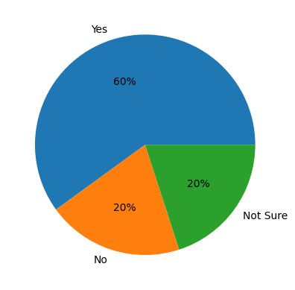

Figure 4.7.1: Improvement in Financial Stability

Position in Wealth Accumulation over a Long Period

The analysis also indicates that majority of the respondents (65 percent) think that investing in gold and silver will help to build wealth in the long term, though 20 percent are not sure, and 15 percent do not believe that. This implies that most investors believe that precious metals are a good instrument in creating wealth in the long-term.

Gold especially is considered to be an asset of the long-term that retains the value and hedges against inflation and is therefore fitting to accumulate wealth. Silver is also considered to be more volatile but can yield returns over time, particularly when it is bought when it is cheaper.

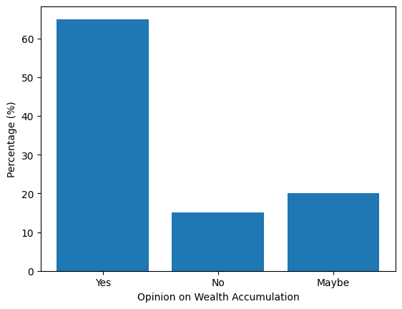

Figure 4.7.2: Opinion on Long-term Wealth Accumulation

Level of Satisfaction with Investment Returns

One of the significant measures of financial stability is investment satisfaction. The data show that half of the respondents (55) are happy with their returns on investment and 25 are unhappy with their returns and 20 remain neutral.

The fairly good level of satisfaction implies that the majority of the investors get their financial expectations, especially in the areas of stability and slow growth. Nonetheless, these signs of dissatisfaction among a section of the respondents could be associated with market volatility, unmet expectation of returns or insufficient diversification in investments.

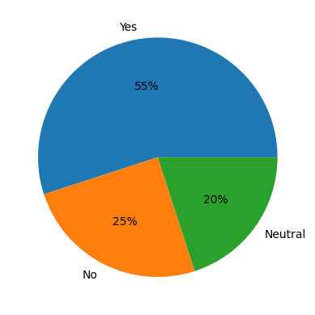

Figure 4.7.3: Satisfaction Level of Respondents

Financial Impact Interpretation

The results suggest that investments in gold and silver are also an important factor in improving financial stability of the middle-class people. The fact that the number of respondents who said they improved is high is an indication that these assets give them the feeling of security and financial assurance.

The perception of wealth accumulation over the long run also strengthens the need of precious metals as an investment option of strategic choice especially to those people who are more inclined towards low-risk investing. But, the ambivalent degree of satisfaction underlines the possibility of different investment outcomes depending on the time, market, and personal expectations.

The findings also indicate that the middle-income earners invest in gold and silver as not just investment vehicles, but also as financial insurance, particularly in times of economic crisis.

Table 4.7: Impact of Investment on Financial Stability
Indicator | Response | Frequency | Percentage (%)
Financial Stability Improved | Yes | 60 | 60%
 | No | 20 | 20%
 | Not Sure | 20 | 20%
Wealth Accumulation Belief | Yes | 65 | 65%
 | No | 15 | 15%
 | Maybe | 20 | 20%
Satisfaction with Returns | Yes | 55 | 55%
 | No | 25 | 25%
 | Neutral | 20 | 20%

Summary

The discussion, in general, reveals that investing in gold and silver have a positive impact on the financial wellbeing of the middle-class investors. The majority of the respondents respond that they have improved their financial position, expect to continue accumulating wealth in the long-term, and are happy with their investment returns. These studies have led to the conclusion that the precious metals are useful financial means of providing security and stability particularly during unstable economic periods.

4.8 Statistical Analysis

Descriptive Statistics

The central tendency and variability of important variables to be measured using Likert-scale responses are summarized using descriptive statistics. These results indicate that the respondents have an overall tendency towards stability and low-risk investments.

The mean rating of the statement Gold, it provides the long-term financial security, is 4.2 and, therefore, the respondents strongly agree with it. Similarly, with respect to Preference for low- risk investment, the mean score is 4.1 showing that there is observable risk-averse nature of investors in the middle classes.

The Precious metals protect against inflation statement has a mean of 4.0 and this implies that many of the respondents believe that gold and silver is protective against the uncertainty in the economy. Mean score of Silver which is characterized by more return opportunities is 3.8 which is moderate agreement and equal perception of risk and return. The level of confidence in the investment decisions is not so high and the mean score is 3.6 which implies that there is some uncertainty among the investors.

Table 4.8.1: Descriptive Statistics of Key Variables
Variable | Mean | Standard Deviation
Gold provides financial security | 4.2 | 0.75
Silver offers higher returns | 3.8 | 0.85
Preference for low-risk investment | 4.1 | 0.70
Precious metals hedge against inflation | 4.0 | 0.80
Confidence in investment decisions | 3.6 | 0.90
The relatively low standard deviations indicate that responses are closely clustered around the mean, suggesting consistency in respondents’ opinions.

Correlation Analysis

The strength and direction of the relationships between the selected variables are measured by the correlation analysis. The findings suggest a number of significant correlations:

Income level correlates positively with amount invested (r 0.45), such that the higher the income, the more they would invest.
- A high positive correlation is found between risk aversion and gold preferences (r 0.60) indicating that risk-averse individuals tend to invest more in gold.
- Emotional influence and investment decision (r 0.50) The relationship between behavioral factors and investment decision shows that the factors of emotions can have a significant impact.

These associations confirm that both economic (income) and behavioral (risk perception and emotions) aspects are significant in the process of investment decision-making.

Table 4.8.2: Correlation Matrix
Variables | Income | Risk Aversion | Gold Preference | Emotional Influence
Income | 1.00
Risk Aversion | 0.30 | 1.00
Gold Preference | 0.40 | 0.60 | 1.00
Emotional Influence | 0.20 | 0.50 | 0.45 | 1.00
The correlation matrix highlights that risk aversion has the strongest relationship with gold preference, reinforcing the idea that gold is chosen as a safer investment option.

Interpretation of Statistical Results
The statistical findings confirm that the behavior of middle-class investment is based on a complex of financial possibilities and psychological condition. Higher income will translate to higher investment and one of the factors that will determine the type of investment asset to choose is the perceived risk.
The fact that gold is most preferred investment among the respondents is explained by the close relationship between the risk aversion and the preference of gold. Another consequence of the strength of feelings is that investment decisions are irrational and prone to behavioral biases.
The medium level of confidence of the respondents also indicates that the investors are not ignorant of investment opportunities, but they may lack the knowledge or experience of making a confident investment decision.

Summary
In general, the statistical data show that income, risk perception, and behavioral factors are influential in the decision-making process in investment. The preference of middle-class investors towards low-risk investments like gold and yet they are aware of the high returns in silver. These results support the traditional finance theory and behavioral finance ideas, giving a holistic account of the investment behavior.

4.9 Key Findings
This section presents the main findings of the research once the data annotated on 100 middle-class subjects concerning their behavior and outcomes of investing in gold and silver were completed.
The demographic profile shows that the respondents are predominantly young and middle-aged educated and economically active people, which suggests that they are also the participants of the financial decision-making process. The majority of the respondents are aged between 25-45 years and have a Bachelor’s degree or higher implying that they have a fair amount of knowledge on investment opportunities.
The income and saving pattern show that the respondents are in the middle-income group that has the highest number of respondents earning between 20,000-40,000 BDT. The percentage (70) of them who invest regularly and most of them invest a percentage of 10-20 of their earnings. This is an indication of a moderate financial strategy, in which people save and handle their daily spending.
In terms of the preferred investment preferences, the findings indicate that the best preferred investment preference is gold with half of the respondent’s giving gold as the preferred investment preference and 30 percent giving both gold and silver. Silver is not that popular, only 15% of the people prefer it as their main investment. This brings out the superiority of gold as a conventional and safe investment tool.
The influencing factor analysis shows that the financial knowledge (30) and market trends (25) are the most significant factors that determine investment decisions. Still, there is also a significant role of emotions as 65 percent of the respondents said that emotion is a consideration in their investment choice and 40 percent of them followed other factors and then invested, which depicts the presence of herd behavior.
The comparison between gold and silver indicates that gold is considered a low risk, stable and culturally valuable investment and silver is considered a high-risk investment, which may be more valuable. This difference is explained by the fact that the investors who are risk averse are utilizing gold, and silver is viewed as supporting or even an alternative.
The risk-averse investor is the middle-class and the risk perception analysis and the analysis of returns expectation justify the risk-aversion of these investors who are likely to choose safe investments. Respondents are overwhelmingly affirmative that gold offers a long-term financial stability and precious metals are hedged against inflation. Silver, though with better returns potential is not very attractive due to its volatility.
The impact analysis reveals that 60 percent of the respondents experienced increased financial stability due to gold and silver investment and 65 percent of the respondents believe that these investments do contribute to wealth accumulation in the long-term. Also, 55 percent of the respondents have been satisfied with their investment returns implying a fairly positive result.
These conclusions are also supported by the statistical analysis that shows that the income level, risk perception and emotional aspects have a significant impact on investment behavior. There is a significant positive correlation between risk aversion and preference towards gold, and income has a positive correlation with the amount of investment.
Overall, the findings of the research indicate that financial stability, security and cultural similarity rank higher in the minds of middle-income investors in making investment decisions. The most preferred kind of investment is gold due to its perceived to be the safest and long-term investment and silver is the second choice which is a cheaper and risky investment. The findings highlight the importance of economic, social and behavioral factors in influencing investment behavior in the middle-class individuals.

CHAPTER 5: DISCUSSION
5.1 Summary of Findings
The behavior of the middle-class and the impact of the investment in gold and silver on the economic welfare of the middle-class has been discussed in this paper. The findings indicate that the majority of the respondents belong to the economically active and educated segment and it is the factor that leads to their involvement in financial decision-making. The income distribution will provide that the respondents will be in the middle-income group where most of them will be earning between 20,000-60,000 BDT.
The savings and investment behaviour analysis indicated that 70 percent of the respondents regularly invest with majority of them spending 10-20 percent of their income on investment. This means that there is a balanced financial strategy in which people are able to balance between consumption and saving.
In the case of the investment preferences, gold is the most preferred as 50 percent of the participants have gold as the first choice, and 30 percent have invested in both gold and silver. Silver is the second option, and it is the most popular option as it is cheaper and offers higher returns.
The study also notes that the most important influencing factors are financial knowledge and market trends, even though behavior aspects of emotion and herd behavior are also important factors in driving investment choices. The proportion of those respondents who responded that they get influenced by emotions when making investment decisions is high (65%).
The comparative analysis indicates that, gold has been considered as low risk and stable commodity compared with silver that is considered as more volatile but can earn higher payoff. The results also show that 60 percent of the respondents had greater financial stability and 65 percent respondents believe in the importance of precious metals in wealth accumulation over long term.

5.2 Interpretation of Results
The results indicate that the middle-income investors have a risk-averse and security-based investment behavior. The financial risk to be minimized and the assurance of the stability in the long run is an attraction that is huge towards gold. This action may be viewed as a logical reaction to income constraints and economic uncertainty, in which people more focus on capital conservation than on hypothetical profits.
The moderate rate of investment (10-20 percent of income) shows that middle-class investors have a conservative financial plan, and they balance current consumption and financial requirements of the future. This can be attributed to the economic theory of savings, which says that individuals invest to acquire a certain degree of financial security.
Factors of influence that reveal that investment decision is not rational are behavioral factors such as emotions and herd behavior. Rather, they are influenced by psychological biases and social forces and this can give rise to suboptimal results. To provide an example, decision-making can be limited by adhering to the market trends or family recommendations.
The fact that the investment in gold and silver positively affect the financial stability implies that these financial tools can be taken as reliable financial tools, particularly in the unpredictable economic environment. The difference in levels of satisfaction however shows that level of performance of investment is dependent on timing, knowledge and market conditions.

5.3 Comparison with the Existing Research
The findings of the current paper agree with the existing literature on investment behaviour and precious metals. A study by Baur and McDermott (2010) and Baur and Lucey (2010) has established that gold is a safe-haven asset more so during financial turmoil. This is in line with the existing research that shows that gold is viewed as a safe, and trustworthy investment.
Similarly, Hillier et al. (2006) have pointed out the diversification benefit of precious metals that explain the existence of respondents who would want to invest in both gold and silver. The perception of silver as a more risky, more profitable asset is also agreeable to the findings of Lucey and Tully (2006) that concentrated on the volatility of silver price.
Based on behavioral finance studies, such as those of Kahneman and Tversky (1979) and Shiller (2003), psychological biases have been suggested to influence investment decisions. This has been validated in the current study since a significant proportion of the participants are identified to be driven by emotions and social aspects in their investment choices.
However, the current paper is an extension of existing literature because it specifically focuses on middle-class investors in a developing country context where the socio-cultural factors, in particular, the cultural value of gold is a more prominent one as compared to the developed economies.

5.4 Relate to Theoretical Framework
The findings of this paper are a decent argument in support of the traditional financial theory and the behavioral finance theory. Conventional finance dictates that the aim of an investor is to make maximized returns, and to minimize risk. Such principle is expressed in the fact that the respondents choose gold as the low-risk investment since they are interested in stability and long-term security.
At the same time, the results are a definite sign of the relevance of the behavioral finance theory, namely, the Prospect Theory (Kahneman and Tversky, 1979). High risk aversion that was evident among the respondents can be likened to the concept of loss aversion whereby, individuals would not want to experience a loss rather than pursue gains.
The existence of herd behavior and emotion also leads to the thought of behavioral finance, i.e. that investment decisions are more likely to be made based on social and psychological factors and not necessarily to be made based on rational analysis.
Also, the results are connected with the idea of diversifying portfolio since a part of the respondents invests in both gold and silver in order to diversify risk and reward. This implies that there is a slow migration towards more sophisticated investment strategies by middle-class investors.

5.5 Study Implications
The implications of the findings of this study are important to the investors, policymakers and financial institutions. The research paper also indicates to middle-class investors the importance of financial planning and diversification. Although gold is stable, reliance on a single asset may be a limitation to potential returns. Thus, investors need to think on diversifying their portfolios by investing in various ways.
The findings highlight the importance of encouraging financial literacy and awareness initiatives to policymakers. The average degree of confidence as well as the role of behavioral factors indicate that a large number of investors are not knowledgeable enough to make sound decisions. Educating people to become more aware of the risk and returns dynamics can be achieved through enhancing financial education.
These findings can be utilized by financial institutions in order to create investment products that are specific to the middle-class investors with low-risk and accessible products. It is also possible to stimulate more systematic investment behavior by introducing systematic plans of investing in gold and silver.
Lastly, the research has a contribution to the academic research as it helps understand the interaction between economic, social, and psychological factors on investment behavior in a developing country.

CHAPTER 6: CONCLUSION AND RECOMMENDATIONS
6.1 Conclusion
The paper was intended to examine the behavior of middle-income citizens and the way in which investment in gold and silver could bring about financial stability of these citizens. After analyzing the received data on 100 respondents, the findings reveal that the middle-class investors are even-handed but risk-averse to investment and it is a matter of economic and behavioral factors.
The results indicate that gold remains as one of the most popular among the middle-class population since it is considered a very stable one, not risky, and with a tremendous cultural value. Silver is a second option investment since it is more volatile and is less trusted by the investors, although it is known to be cheap and has better returns than other investments.
The other dimension of risk-aversive behavior that was observed in the investigation is the middle-class investors who are likely to invest in safe and reliable methods of investment rather than investing in high risks. This has been reflected in their average investment levels since most of the respondents’ used 10-20 percent of their income to invest.
In addition, the findings have shown that it is the financial literacy and market tendencies that are critical determinants of the type of investment made, although the behavioral dimension, such as the feelings and socialization, influences significantly. The presence of herd behavior and emotional decision-making shows that investment behavior is not necessarily rational.
Interestingly, the study substantiates the argument that investment in gold and silver is positively correlated with the financial stability and a majority of the respondents indicated that they are financially stable and have long term wealth. In conclusion, the research discovers that precious metals can be applied in financial security and stability particularly to the middle-class investors in the developing economies.

6.2 Recommendations
Based on the findings of the study, one can come up with several suggestions that would help to improve the conduct of the middle-class population in terms of investments and financial performance.
To start with, investors need to embrace diversified investment approach as opposed to investing in gold only. Unlike gold, which provides stability, other assets such as silver or financial instruments can be utilized in order to enhance the probability of returns and reduce the overall risk.
Second, the middle-class investors need to work on their financial literacy. Understanding of market trends and risk-return relationships and investment decisions can help individuals to make superior and sensible decisions.
Third, investors should not make the decisions based on emotions and social pressure only. Rather, they need to base their efforts on the correct financial analysis and long-term planning to produce more effective results.
Fourth, individuals should create an institutionalized routine of investment where the percentage of income to allocate at a given time on a regular basis and not investing here and there based on the market conditions.
Finally, and lastly, awareness should be generated on the potential of silver as alternative investment, particularly to those who are financially constrained, as it is cheap and is diversified.

6.3 Policy Implications
The implications of this research study to the policy makers and financial institutions are very important both on policy and financially. The need to campaign financial education programs which can make people in the middle classes more aware of investment opportunities and risk management is high.
The government and financial authorities need to encourage the establishment of open and transparent platforms to invest in gold and silver, where individuals will be able to invest money in a more structured and secure manner. This involves facilitating online investment opportunities like financial products that are backed by gold.
The policies should also aim at ensuring that the market is stable and the prices are transparent to ensure that the investors get the right information to make an informed decision. This may be used to minimize volatility in the market and improve regulatory frameworks to increase investor confidence.
Also, financial institutions will be able to create investment products to meet the needs of the middle-class investors in terms of low-risk and flexible products that would fit their financial ability and tastes.

6.4 Study Limitations
Although it has its contributions, this study has various limitations, which ought to be recognized. To start with, the sample size of 100 respondents is limited which can limit the generalization of the results to the general population.
Second, the study uses the convenience sampling technique that is able to form bias and limits sample representativeness. The findings may not be a completely precise representation of the practices of all the middle-class individuals.
Third, the research is done based on self-reported data that may be biased or inaccurate. The respondents may not be consistently able to be completely sincere about their information as to their financial behavior.
Fourth, the study is restricted to the gold and silver investment and not the other investment such as stocks, bonds and real estate, which would provide us with a well-rounded outlook of the nature of investment.
Lastly, the cross-sectional character of the study will not allow studying the changes in investment behavior over time.

6.5 Suggestions for Future Research
Future researchers can use the study to create a more in-depth understanding of investment behaviour by addressing its weaknesses and factoring in new dimensions of investment behaviour. To begin with, the study can be conducted in a more varied and larger sample that includes respondents in other areas and socio-economic backgrounds to increase the generalizability.
Second, the future research can be longitudinal and concentrate on the changes in investment behavior with time, particularly the response to the changes in the economy and market conditions.
Third, researchers can use a more comprehensive range of investment instruments (stocks, mutual funds, and digital assets) to offer a more valuable study of investment behavior.
Fourth, it is also possible to explore the psychological and behavioral characteristics of investment decisions with the help of the qualitative research methods (interviews and case studies).
Lastly, areas of future research can be directed towards examining how financial literacy and education can enhance investment behavior, especially among middle-class people in the developing world.

REFERENCES
Banerjee, A. V., and Duflo, E. (2008). What is middle class about the middle classes around the world? Journal of Economic Perspectives, 22(2), 3–28.
https://doi.org/10.1257/jep.22.2.3
Barberis, N., and Thaler, R. (2003). A survey of behavioral finance. In G. Constantinides, M. Harris, and R. Stulz (Eds.), Handbook of the Economics of Finance (Vol. 1, pp. 1053–1128). Elsevier.
https://doi.org/10.1016/S1574-0102(03)01027-6
Batten, J. A., Ciner, C., and Lucey, B. M. (2014). On the economic determinants of the gold–inflation relation. Resources Policy, 41, 101–108.
https://doi.org/10.1016/j.resourpol.2014.03.007
Baur, D. G., and Lucey, B. M. (2010). Is gold a hedge or a safe haven? An analysis of stocks, bonds and gold. Financial Review, 45(2), 217–229.
https://doi.org/10.1111/j.1540-6288.2010.00244.x
Baur, D. G., and McDermott, T. K. (2010). Is gold a safe haven? International evidence. Journal of Banking and Finance, 34(8), 1886–1898.
https://doi.org/10.1016/j.jbankfin.2009.12.008
Baur, D. G., and Tran, D. T. (2014). The long-run relationship of gold and silver and the influence of bubbles and financial crises. Empirical Economics, 47(4), 1525–1541.
https://doi.org/10.1007/s00181-014-0813-1
Gorton, G., and Rouwenhorst, K. G. (2006). Facts and fantasies about commodity futures. Financial Analysts Journal, 62(2), 47–68.
https://doi.org/10.2469/faj.v62.n2.4083
Hillier, D., Draper, P., and Faff, R. (2006). Do precious metals shine? Financial Analysts Journal, 62(2), 98–106.
https://doi.org/10.2469/faj.v62.n2.4085
Kahneman, D., and Tversky, A. (1979). Prospect theory: An analysis of decision under risk. Econometrica, 47(2), 263–291.
https://doi.org/10.2307/1914185
Keynes, J. M. (1936). The general theory of employment, interest and money. Macmillan.
https://www.marxists.org/reference/subject/economics/keynes/general-theory/
Lucey, B. M., and Tully, E. (2006). Seasonality, risk and return in the gold and silver markets. Applied Financial Economics, 16(4), 319–333.
https://doi.org/10.1080/09603100500390861
Lusardi, A., and Mitchell, O. S. (2014). The economic importance of financial literacy. Journal of Economic Literature, 52(1), 5–44.
https://doi.org/10.1257/jel.52.1.5
Markowitz, H. (1952). Portfolio selection. Journal of Finance, 7(1), 77–91.
https://doi.org/10.1111/j.1540-6261.1952.tb01525.x
Shiller, R. J. (2003). From efficient markets theory to behavioral finance. Journal of Economic Perspectives, 17(1), 83–104.
https://doi.org/10.1257/089533003321164967

APPENDICES
Appendix A: Questionnaire
Title: Survey on Middle-Class Behavior and Impact in Gold and Silver Investment

Section A: Demographic Information
- Gender:
☐ Male ☐ Female ☐ Other
- Age Group:
☐ Below 25 ☐ 25–35 ☐ 36–45 ☐ 46–55 ☐ Above 55
- Educational Qualification:
☐ Secondary ☐ Higher Secondary ☐ Bachelor’s ☐ Master’s ☐ Others
- Occupation:
☐ Service ☐ Business ☐ Student ☐ Self-employed ☐ Others
- Monthly Income (BDT):
☐ Below 20,000
☐ 20,000–40,000
☐ 40,001–60,000
☐ 60,001–100,000
☐ Above 100,000

Section B: Investment Behavior
- Do you invest regularly?
☐ Yes ☐ No
- Which type of investment do you prefer most?
☐ Gold ☐ Silver ☐ Both ☐ Others
- What is your main purpose of investment?
☐ Savings ☐ Profit ☐ Security ☐ Social/Cultural Reasons
- How frequently do you invest in precious metals?
☐ Regularly ☐ Occasionally ☐ Rarely ☐ Never
- What percentage of your income do you invest?
☐ Below 10% ☐ 10–20% ☐ 21–30% ☐ Above 30%

Section C: Gold and Silver Investment
- Which metal do you consider more reliable?
☐ Gold ☐ Silver ☐ Both ☐ None
- Why do you prefer gold investment?
☐ Stability ☐ Cultural value ☐ Easy resale ☐ Low risk
- Why do you prefer silver investment?
☐ Low cost ☐ Higher return ☐ Industrial demand ☐ Accessibility
- Do you think gold is a safe investment?
☐ Strongly Agree ☐ Agree ☐ Neutral ☐ Disagree ☐ Strongly Disagree
- Do you think silver is more volatile than gold?
☐ Strongly Agree ☐ Agree ☐ Neutral ☐ Disagree ☐ Strongly Disagree

Section D: Risk and Return Perception (Likert Scale)
(1 = Strongly Disagree, 5 = Strongly Agree)
Statement | 1 | 2 | 3 | 4 | 5
Gold provides long-term financial security | ☐ | ☐ | ☐ | ☐ | ☐
Silver offers higher return opportunities | ☐ | ☐ | ☐ | ☐ | ☐
I prefer low-risk investments over high returns | ☐ | ☐ | ☐ | ☐ | ☐
Precious metals protect against inflation | ☐ | ☐ | ☐ | ☐ | ☐
I feel confident in my investment decisions | ☐ | ☐ | ☐ | ☐ | ☐

Section E: Behavioral Factors
- What influences your investment decision the most?
☐ Family ☐ Friends ☐ Media ☐ Financial Knowledge ☐ Market Trends
- Do you follow others when making investment decisions?
☐ Yes ☐ No
- Do emotions (fear, greed) affect your investment decisions?
☐ Yes ☐ No
- Do you prefer traditional investments over modern financial instruments?
☐ Yes ☐ No

Section F: Impact of Investment
- Has gold/silver investment improved your financial stability?
☐ Yes ☐ No ☐ Not Sure
- Do you believe investing in precious metals helps in long-term wealth accumulation?
☐ Yes ☐ No ☐ Maybe
- Are you satisfied with your current investment returns?
☐ Yes ☐ No ☐ Neutral

Closing Statement
Thank you for your valuable time and participation. Your responses are highly appreciated and will contribute significantly to this research study.

